WELCOME TO EMMANUEL

Emmanuel Episcopal Church was established in 1858. The first wooden structure was destroyed by a storm. The present building was erected in 1872 on a meager budget by faithful souls. They dug native fieldstone from nearby farms and used sand from Lee County creeks to make the mortar. For many years the interior was largely bare and furnishings were slowly added. The Church is the oldest public building in the city of Opelika and among the oldest buildings in Lee County. Emmanuel has been a mission church for most of the 150 years of its existence. In 1996, the architectural firm of Holmes & Holmes of Mobile, Alabama was employed to plan and supervise the renovation of the original building. The firm was asked to maintain the building’s architectural integrity, so while structural problems were corrected, the original appearance of the chancel was largely restored.

Emmanuel Episcopal Church is located at 800 First Avenue, Opelika, Alabama 36801. For more information call the Parish Office at (334) 745-2054 or send an e-mail to emmanuelopelika@bellsouth.net Visit us online at www.opiscopal.org. If you are a guest, please sign our church guest book by the front door.

TODAY’S LAY EUCHARIST MINISTERS

Lay Eucharist Minister Nancy Jonson
Organist & Music Director Preston Winkles

EMMANUEL EPISCOPAL CHURCH
800 First Ave.
Opelika, Alabama 36801

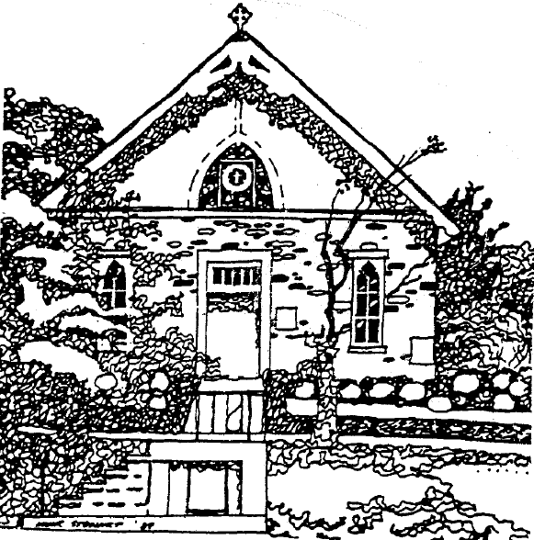

The Day of Pentecost: Whitsunday
Morning Prayer – Rite II

May 28, 2023

Order of Worship

Prelude
Entrance Hymn Come Down, O Love Divine Hymnal 516
Word of God BCP Page 77
Confession of Sin BCP Page 79
Invitatory BCP Page 80
Christ our Passover BCP Page 83
Psalm 104:25-35, 37 Insert
Gloria Patri Insert

The Liturgy of the Word

First Reading – Acts: 2:1-21 Insert
A Song of Praise BCP Page 90
Second Reading – 1 Corinthians 12:3-13 Insert
The Song of the Redeemed BCP Page 94
Gospel – John 20:19-23 Insert
Reflection The Catechism BCP Page 849-854
Meditation Hymn Come, Holy Spirit Hymnal 510

The Apostles’ Creed BCP Page 96
Suffrages A BCP Page 97
Collect of the Day Insert
Collect for the Visitation BCP 240
Collect for the Mission of the Church BCP Page 257
Prayers for the Parish BCP Page 817
Prayers for the Victims of Addiction BCP Page 831
Parish Prayer List See Page 3 of Bulletin
The Lord’s Prayer BCP Page 97
The Peace

Offertory Hymn Like the Murmur Hymnal 513
Presentation Hymn Doxology Hymnal 380 (verse 3)
The General Thanksgiving BCP Page 101
Prayer of St. Chrysostom BCP Page 102
Recessional Hymn Holy Spirit, Ever Living Hymnal 511
Dismissal BCP Page 102
Postlude

Prayers of the People

Intercessions for Healing
Filip A., Carol A., Marie A., Petr A., Bob & Cecelia B., Sara B., Tim B., John C., Patrick C., Francie G., Victor G., Jitka H., Rosalie H., Linda H., Sandy H., Judy J., Bob J., Jack K., Meredith K.,
Greg & Ilene L., Jan L., Jay L., Rob L., Tom L., Hiram M., Bill M., John M., Linda M., Robbie M., Matthew P. & family, Demarcos P.,
Mike & Jacqueline R., Ron R., Ann R., Janeth & Fred S.,
Joanne & Bill S., Ken S., Judy W., Blanche W., Frank Y.

In Thanksgiving For: The Children of Emmanuel Church,
Emmanuel’s anonymous donors

For Those Who Have Died:

Announcements
June 4 Vestry meeting following coffee hour
June 5 Inquirer’s class at 6 pm
Refreshments at 5:30 pm
June 8 Compline at 6 pm

Emmanuel’s Service Schedule – Sunday – 10:00
June 4 Holy Eucharist, Rite II – The Rev. Liston A. Garfield
June 11 Morning Prayer, Rite II
June 18 Morning Prayer, Rite II
June 25 Eucharist, Rite II – The Rev. Liston A. Garfield

The people of Emmanuel Church offer a warm welcome to our guests. Please take a moment to sign our guest book near the front door. All baptized Christians of every denomination are encouraged to receive Holy Eucharist. If you are unable to come to the altar rail, please let the usher know you would like to receive the consecrated bread and wine in your pew.

Thank you for your continuing support.

